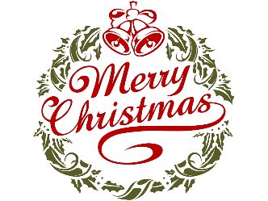
Plymouth Public School
December 2017
Sunday | Monday | Tuesday | Wednesday | Thursday | Friday | Saturday
 |  |  |  |  | 1 – Day 1  Jr/Int trip to see Wonder at Seaway Mall | 2
3 | 4 – Day 2  Christmas Store | 5 – Day 3  Christmas Store | 6 – Day 4  Christmas Store | 7 – Day 5  Pizza Day  Christmas Store  Ms. Parry/Ms. Shields classes to DSBN Adventure Campus | 8 – Day 6  Christmas Store | 9
10 | 11 – Day 7 | 12 – Day 8 | 13 – Day 9 | 14 – Day 10  Pizza Day | 15 – Day 1 | 16
17  Spirit Week!! | 18 – Day 2  Crazy Sweater Day!! | 19 – Day 3  1:40pm & 6pm Christmas Concert Gr. 1-8  Red/Green Day!! | 20- Day 4  2pm – Kindergarten Christmas Concert  Hat Day!! | 21 – Day 5  Pizza Day  Crazy Socks Day!! | 22 – Day 6  Pizza Orders & Milk Money due for January  Pajama Day!! | 23
Christmas Break
December 25 – January 5

 |  |  | School Cash Online – If you have not done so already, sign up. It is easy and convenient to pay for all your child’s school expenses. If you need help, contact the office.

